Reading
Lucy’s blog
<SB S.XXX>


- Read the text. What places are there in Lucy’s area? Tick (✓) the right pictures.

Lies den Text. Welche Orte gibt es in Lucys Gegend? Setze ein Häkchen (✓) bei den richtigen Bildern.

Hi,
I am Lucy. I am twelve years old and I live in Oxford. There are a lot of trees in my street, so it is nice and green. We have got a big playground. There is a little park, too. I go inline skating there. There aren’t many cars and buses on my street. It is really quiet. I like that.
Our house is not very big. We have got a nice garden, too. I often play there with my two rabbits. Our neighbours are very friendly.
In my street there is a swimming pool, a café and a cinema. My parents and I go to the café on Sundays. My school is in my area too, so I can walk there. I have got lots of friends in my area and they all go to my school. That’s great!

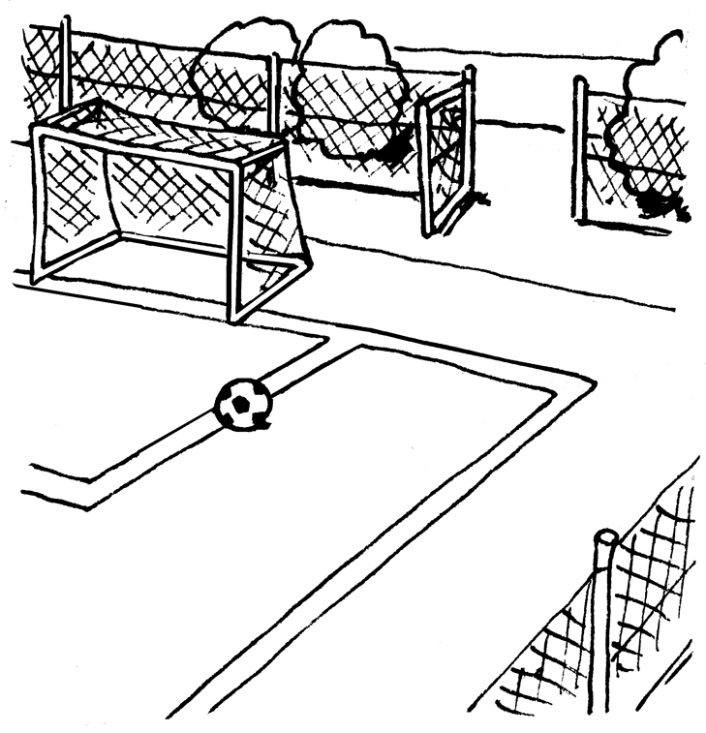 |  | 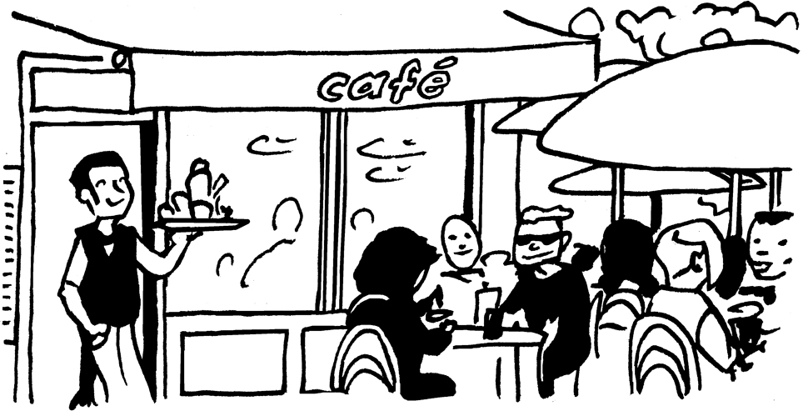 |  | 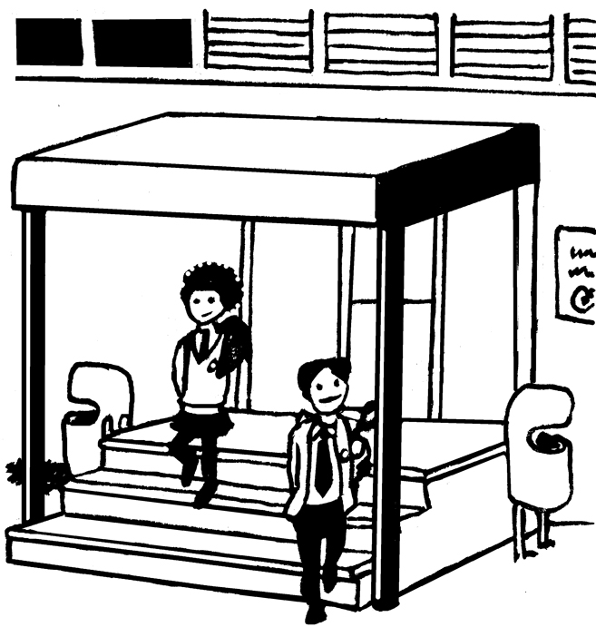  school
––––––
1. |  | 2. |  | 3.
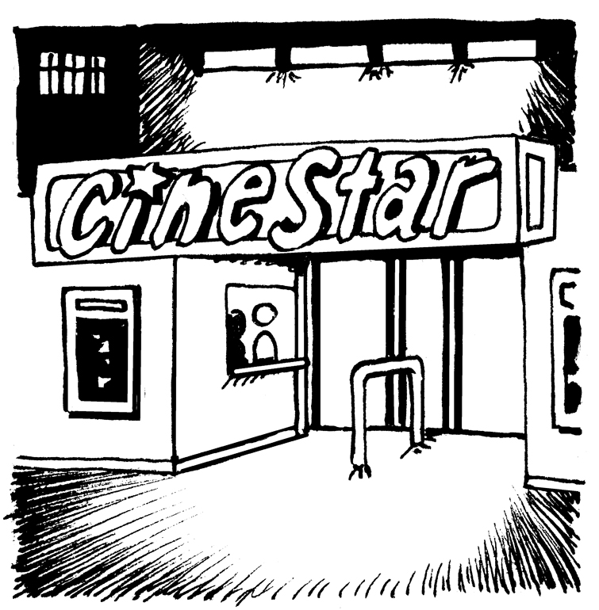  von  5 |  | 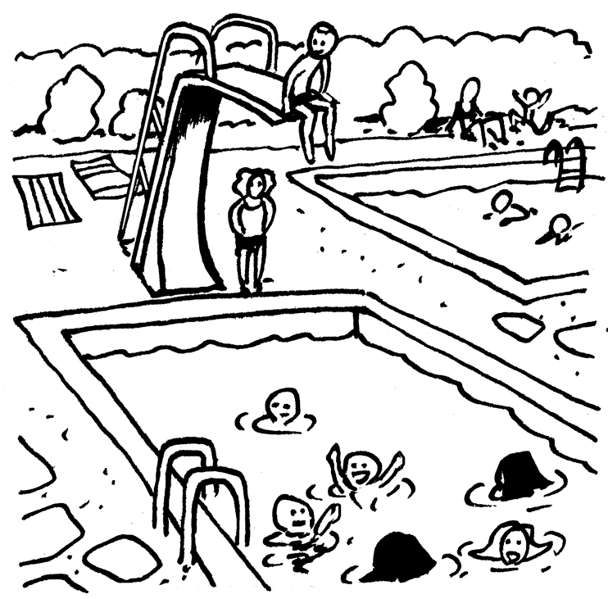 |  | 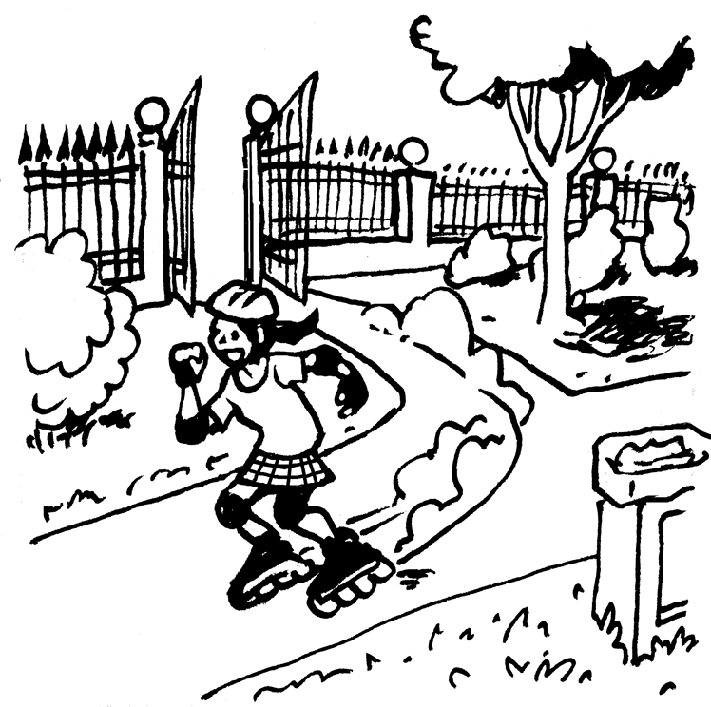
4. |  | 5. |  | 6.

- Read the text again. Tick (✓) the right sentences.
Lies den Text ein zweites Mal. Setze ein Häkchen (✓) für richtig oder falsch.
right wrong
  - Lucy lives in Oxford. –––––––––––––––––––––––––––––––––––––––––––––
  - She likes inline skating in the park. –––––––––––––––––––––––––––––––––
  - Her street is very quiet. ––––––––––––––––––––––––––––––––––––––––––
  - She lives in a house with a garden. –––––––––––––––––––––––––––––––––
  - Lucy has got three rabbits. ––––––––––––––––––––––––––––––––––––––––
  - The neighbours are not nice. ––––––––––––––––––––––––––––––––––––––

von
13
  - On Sundays, she goes to a café with her friends. –––––––––––––––––––––
  - Her school is not in her area. –––––––––––––––––––––––––––––––––––––

